**Introduction: La Dolce Pizza**

Welcome to the documentation of the Food Website, a web application designed to provide you with a delightful experience for browsing through the menu, learning about the restaurant, and getting in touch. This website is built using React, React Router, and custom components.

**Table of Contents**

**Getting Started**

**Project Structure**

**Components**

* Navbar
* Footer
* Home
* MenuItem
* About
* Contact
* Routing

**Pages**

* About
* Contact
* Home
* Menu
* Gallery

**Helper**

* Menulist

**Styles**

* About.css
* Contact.css
* Footer.css
* Gallery.css
* Home.css
* Menu.css
* Navbar.css

**Getting Started**

To run the Food Website on your local machine, follow these steps:

Run **npm start** to start the development server.

The website will be available at [**http://localhost:3000**](http://localhost:3000)**.**

**Project Structure**

The project structure is as follows:

src/ contains the source code.

components/ contains React components used throughout the website.

pages/ contains the main pages of the website.

App.js is the main application component.

index.js is the entry point of the React application.

style/ contains the all the css files linked with the pages

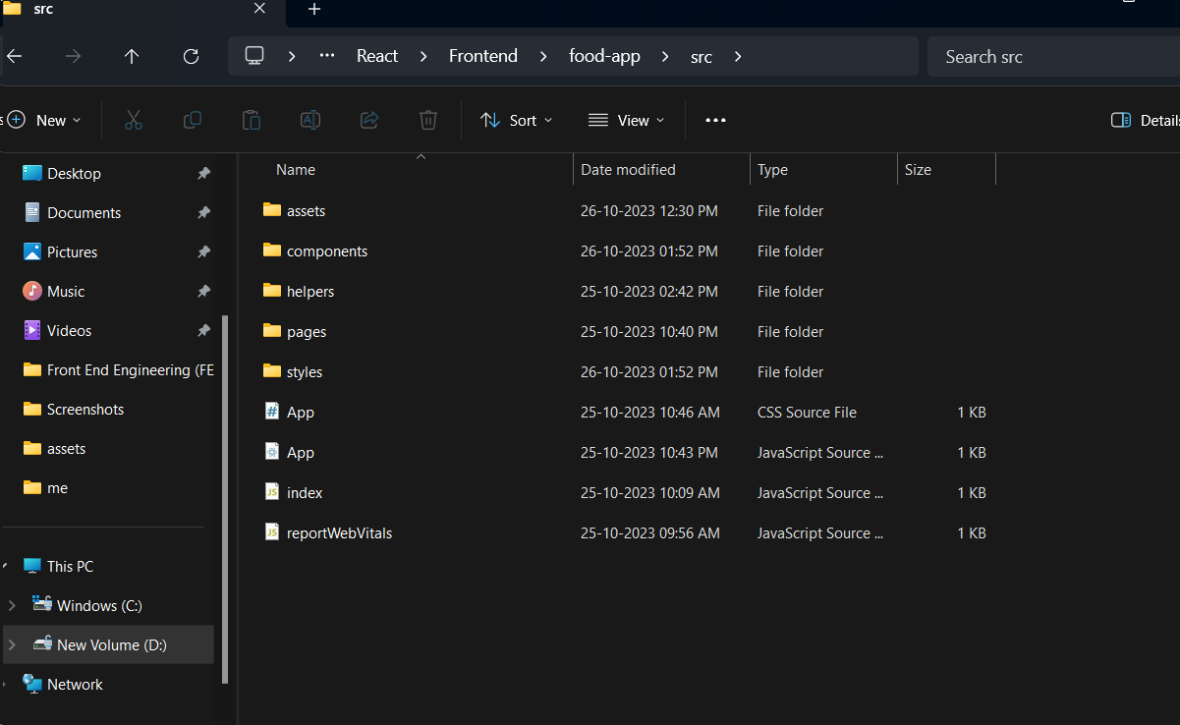

**Components:**

**Navbar**

The Navbar component is responsible for rendering the website's navigation bar at the top of each page. It allows users to navigate to different sections of the website, such as the home, menu, about, and contact pages.

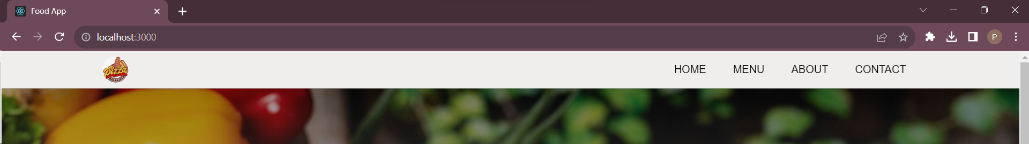

**Footer**

The Footer component displays a simple footer at the bottom of each page. It often contains information like copyright, social media links, and contact details.

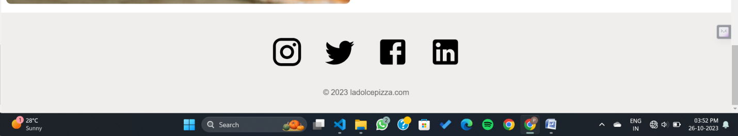

**Home**

The Home page provides a warm welcome to the users and typically includes an image, a description of the restaurant, component to showcase images for same.

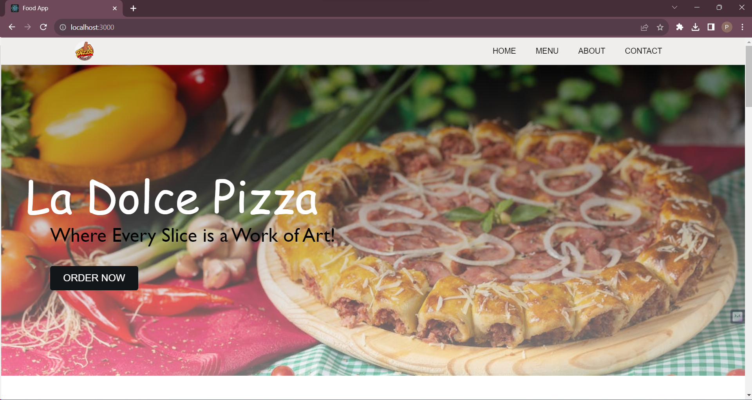

**Menu**

The Menu page displays the restaurant's menu. It can be customized to show different categories of food items, along with descriptions and prices. This is where users can explore the available dishes.

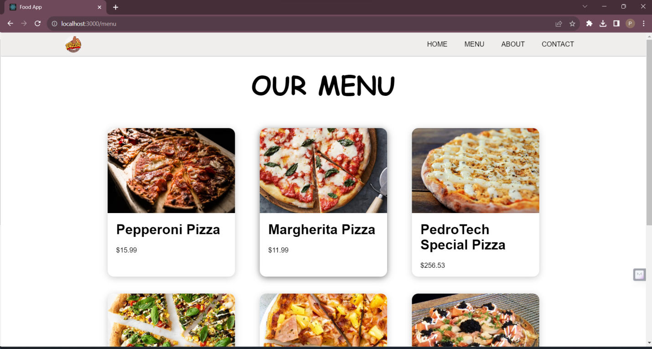

**About**

The About page provides information about the restaurant's history, mission, and values. It allows users to get to know the restaurant better.

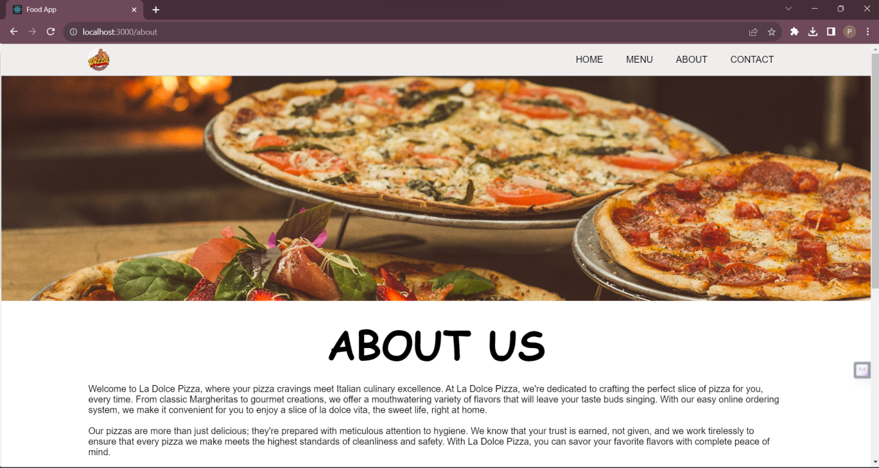

**Contact**

The Contact page displays contact details and may include a contact form or a map showing the restaurant's location. Users can use this page to reach out to the restaurant.

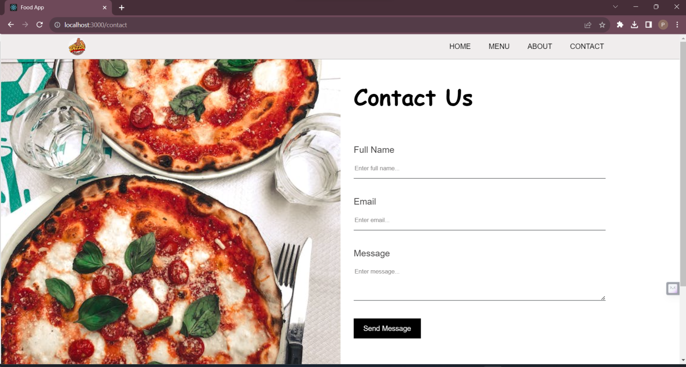

**Gallery**

The Gallery component can showcase images or videos related to the restaurant. It is a visual representation of the restaurant's ambiance, cuisine, or events.

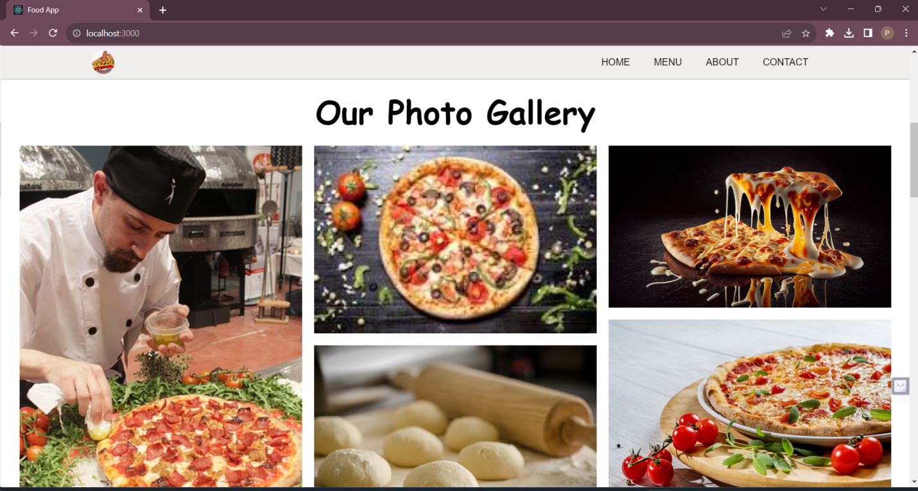

**Routing**

Routing in the Food Website is implemented using React Router. The routing configuration is defined in App.js. It sets up different routes for the pages, so users can navigate between them seamlessly.

The website has the following routes:

/ (Home)

/menu(Menu)

/about (About)

/contact(Contact)

Each route maps to a specific page component and is rendered when users navigate to the corresponding URL.

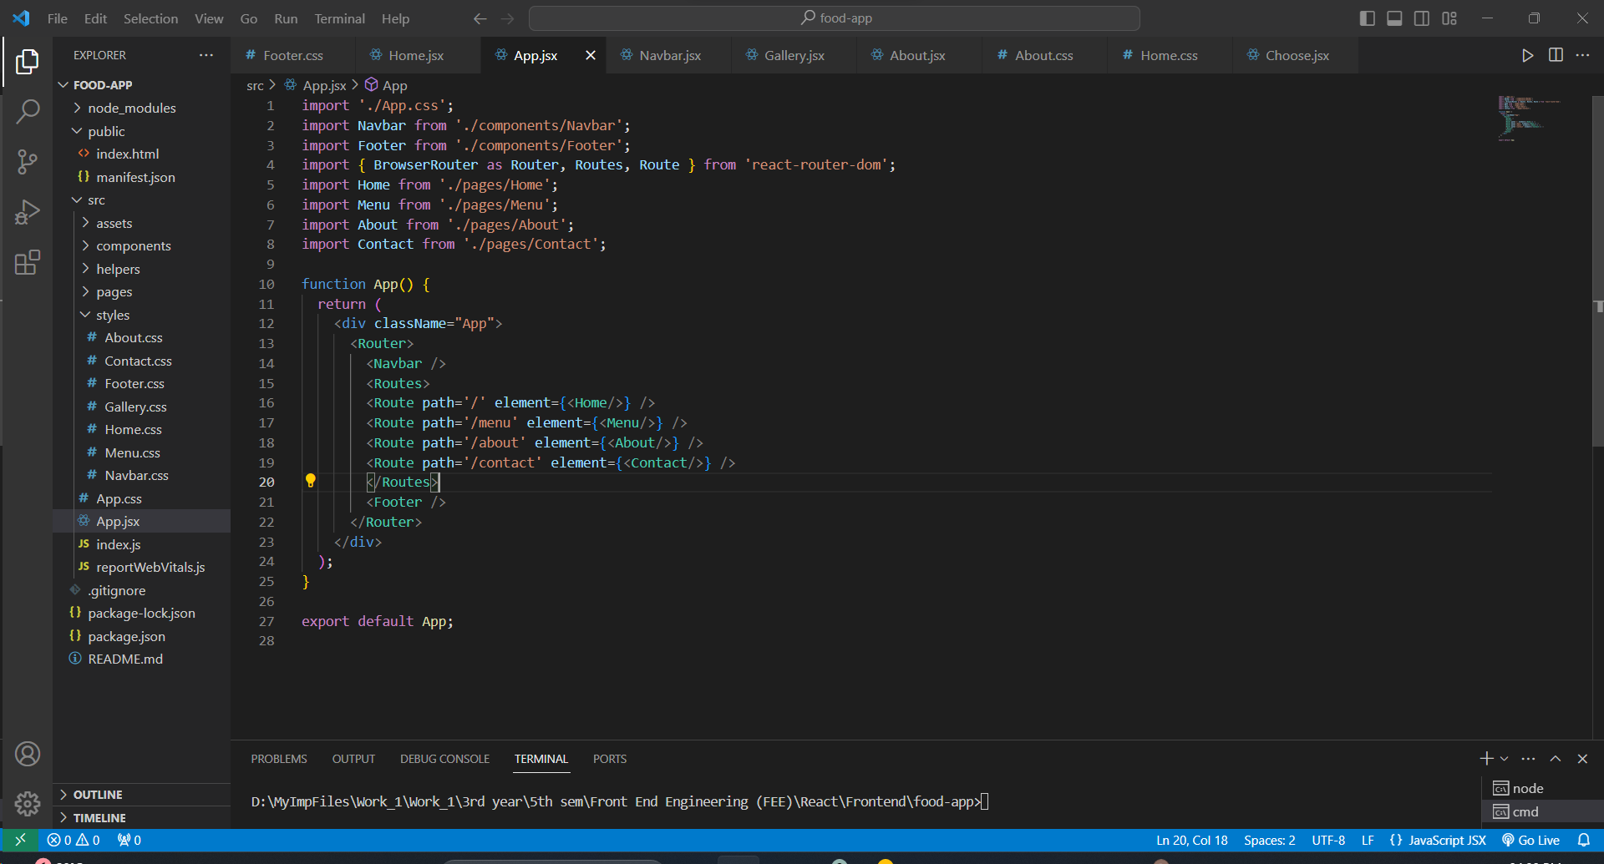

That's it! You now have an overview of the Food Website's structure and components.